# Recorded Steps

This file contains all the steps and information that was recorded to help you describe the recorded steps to others.

Before sharing this file, you should verify the following:

* The steps below accurately describe the recording.
* There is no information below or on any screenshots that you do not want others to see.

Passwords or any other text you typed were not recorded, except for function and shortcut keys that you used.

You can do the following:

* Review the recorded steps
* Review the recorded steps as a slide show
* Review the additional details

# Steps

Previous Next

**Step 1: (‎6/‎15/‎2023 2:53:12 PM)** User left click on "Select an image (text)" in "Action Recognition - Google Chrome"

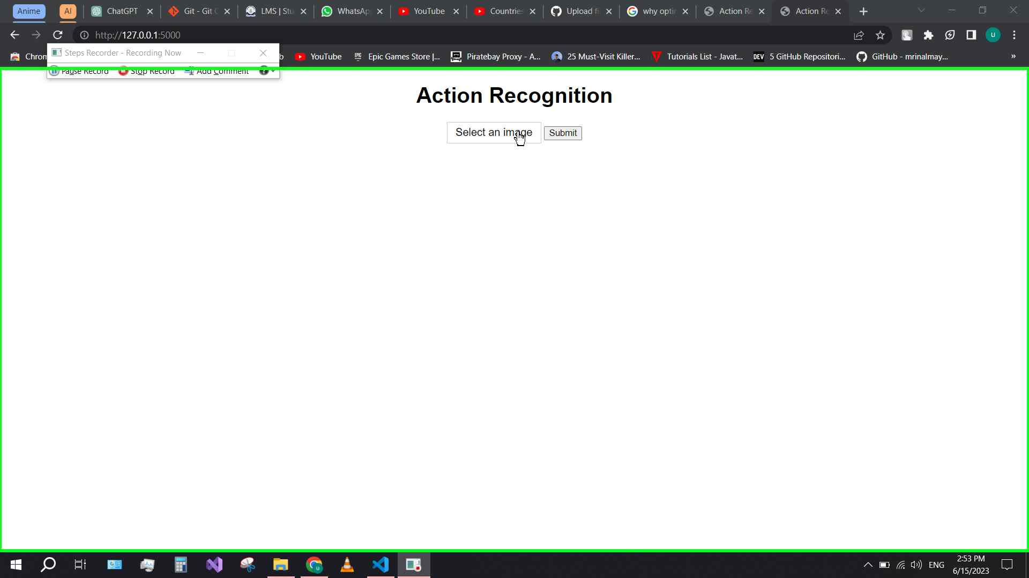Step 1 screenshot.

Previous Next

**Step 2: (‎6/‎15/‎2023 2:53:14 PM)** User left click on "Image_3.jpg (list item)" in "Open"

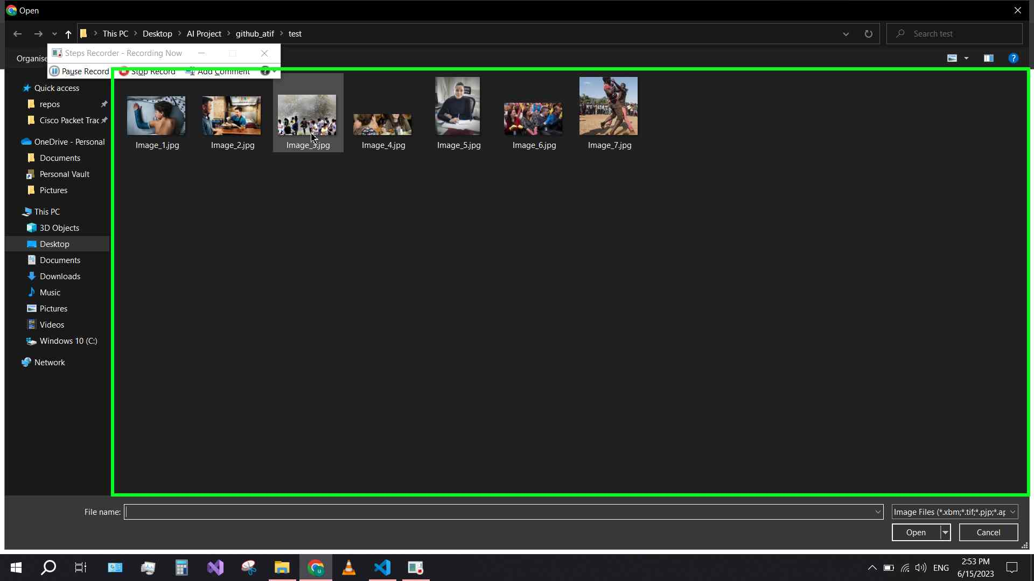Step 2 screenshot.

Previous Next

**Step 3: (‎6/‎15/‎2023 2:53:16 PM)** User left click on "Open (split button)" in "Open"

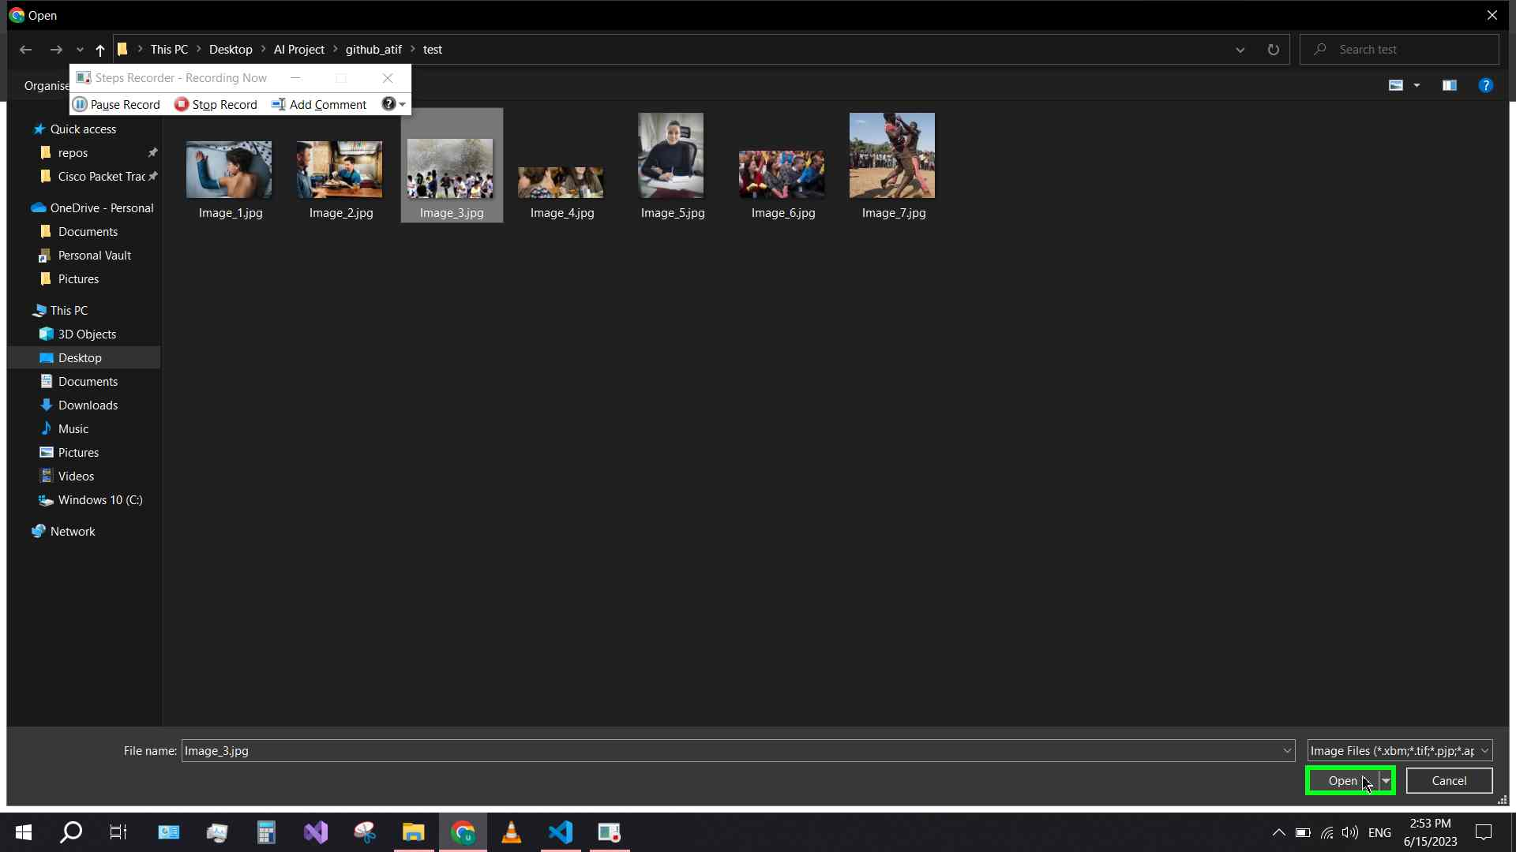Step 3 screenshot.

Previous Next

**Step 4: (‎6/‎15/‎2023 2:53:18 PM)** User left click on "Submit (button)" in "Action Recognition - Google Chrome"

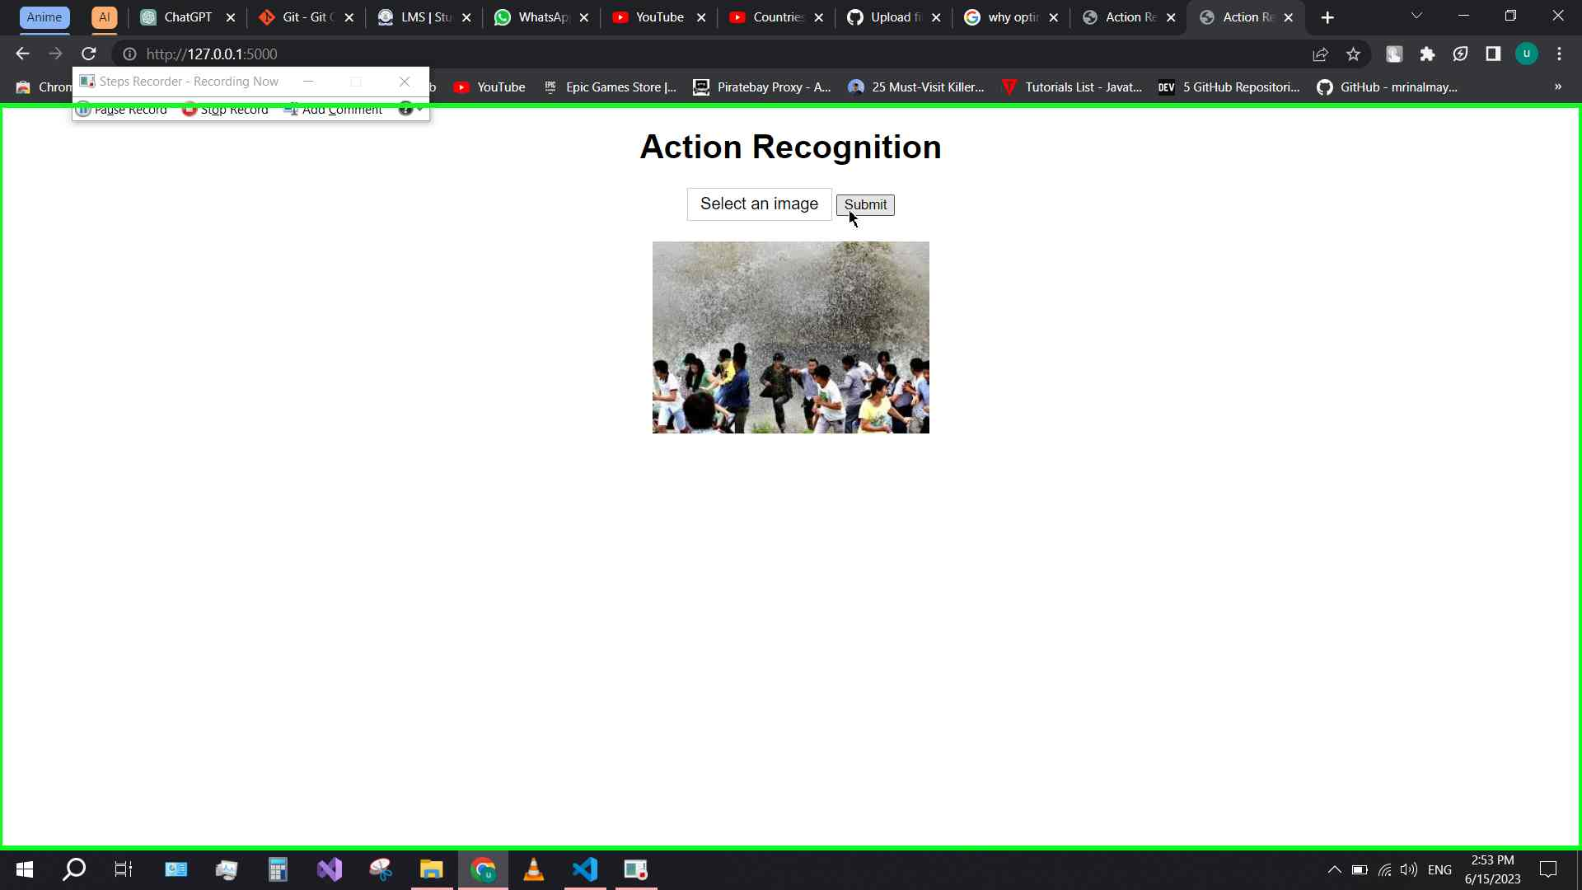Step 4 screenshot.

Return to top of page...

# Additional Details

The following section contains the additional details that were recorded.

These details help accurately identify the programs and UI you used in this recording.

This section may contain text that is internal to programs that only very advanced users or programmers may understand.

Please review these details to ensure that they do not contain any information that you would not like others to see.

*Recording Session: ‎6/‎15/‎2023 2:53:11 PM - 2:53:21 PM  
  
Recorded Steps: 4, Missed Steps: 0, Other Errors: 0  
  
Operating System: 19041.1.amd64fre.vb_release.191206-1406 10.0.0.0.2.4  
  
Step 1: User left click on "Select an image (text)" in "Action Recognition - Google Chrome"  
Program: Google Chrome, 114.0.5735.111, Google LLC, CHROME.EXE --SINGLE-ARGUMENT HTTP://127.0.0.1:5000/, CHROME.EXE  
UI Elements: Select an image, Action Recognition, Chrome_RenderWidgetHostHWND, Action Recognition - Google Chrome - usman, Chrome_WidgetWin_1  
  
Step 2: User left click on "Image_3.jpg (list item)" in "Open"  
Program: Google Chrome, 114.0.5735.111, Google LLC, CHROME.EXE --TYPE=UTILITY --UTILITY-SUB-TYPE=CHROME.MOJOM.UTILWIN --LANG=EN-US --SERVICE-SANDBOX-TYPE=NONE --MOJO-PLATFORM-CHANNEL-HANDLE=10552 --FIELD-TRIAL-HANDLE=1940,I,11571330210042704106,13961141199404679297,262144 --ENABLE-FEATURES=PARALLELDOWNLOADING /PREFETCH:8, CHROME.EXE  
UI Elements: Image_3.jpg, UIItem, Items View, UIItemsView, Shell Folder View, DUIListView, Folder Layout Pane, Element, Explorer Pane, HWNDView, DUIViewWndClassName, Open, #32770, Action Recognition - Google Chrome - usman, Chrome_WidgetWin_1  
  
Step 3: User left click on "Open (split button)" in "Open"  
Program: Google Chrome, 114.0.5735.111, Google LLC, CHROME.EXE --TYPE=UTILITY --UTILITY-SUB-TYPE=CHROME.MOJOM.UTILWIN --LANG=EN-US --SERVICE-SANDBOX-TYPE=NONE --MOJO-PLATFORM-CHANNEL-HANDLE=10552 --FIELD-TRIAL-HANDLE=1940,I,11571330210042704106,13961141199404679297,262144 --ENABLE-FEATURES=PARALLELDOWNLOADING /PREFETCH:8, CHROME.EXE  
UI Elements: Open, Button, Open, #32770, Action Recognition - Google Chrome - usman, Chrome_WidgetWin_1  
  
Step 4: User left click on "Submit (button)" in "Action Recognition - Google Chrome"  
Program: Google Chrome, 114.0.5735.111, Google LLC, CHROME.EXE --SINGLE-ARGUMENT HTTP://127.0.0.1:5000/, CHROME.EXE  
UI Elements: Submit, Action Recognition, Chrome_RenderWidgetHostHWND, Action Recognition - Google Chrome - usman, Chrome_WidgetWin_1*

Return to top of page...